__________________________________________________________________________________

**ABC Smart Watch User Guide**

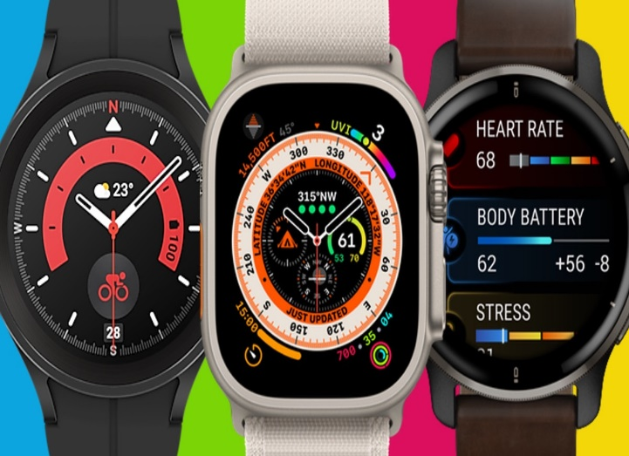

Image Source: [Best smartwatches compared: Options for every budget reviewed - Wareable](https://www.wareable.com/smartwatches/best-smartwatch-reviews-compared-8286)

Thank you for purchasing and using the ABC company’s smartwatch. You can read this manual to fully understand the functions of the watch and the simple method of operation.

**Table of Contents**

1. Basic information
   1. Components…………………………………………………………………………………………………
   2. Parameter …………………………………………………………………………………………………….

2. Setting up your smartwatch ………………………………………………………………………………………………

2.1. Power on the ABC smartwatch…………………………………………………………………………………………..

2.2. Pair my Smartwatch to my phone……………………………………………………………………………………….

2.3. Connectthe Smartwatch to Wi-Fi………………………………………………………………………………………..

2.4. Power off my Smartwatch?.......................................................................................................

3. ABC Smartwatch Features You Need to Consider………………………………………………………………………..

4. Notes……………………………………………………………………………………………………………………………………………

5. FAQ’S…………………………………………………………………………………………………………………………………………….

6 Case study……………………………………………………………………………………………………………………………………….

7 References……………………………………………………………………………………………………………………………………….

**Basic Parameter**

|  |  |
| --- | --- |
| **Product Specifications** | **Details** |
| Bluetooth | BT 4.0 |
| Charging mode | Clip-charging & magnetic-suction type |
| Charging voltage | DC 5V |
| Charging current | 100mA |
| Screen | 1.3 TFT color screen |
| Battery type | Polymer lithium battery |
| Battery capacity | 180mAh |
| Watch material | Zinc alloy or plastic |

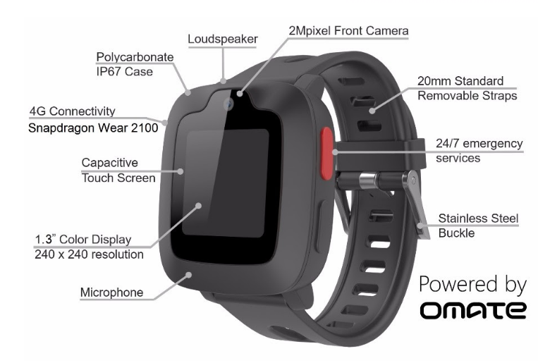

Image Source:[Omate launches smartwatch tailored for 4G video calls at MWC 2017 - HardwareZone.com.sg](https://www.hardwarezone.com.sg/tech-news-omate-launches-smartwatch-tailored-4g-video-calls-mwc-2017)

**Setting up your smartwatch**

**Setting up your ABC Smart Watch is quick and easy, and it works with Android and iOS phones. Full Setting Instructions are given in the sections below,**

2.1

|  |
| --- |
| **Power on the ABC smartwatch** |
| Make sure the smartwatch is charged before trying to power it on. Press and hold down the middle pusher button for at least three seconds. The smartwatch will also power on when connected to the charger. |

2.2

|  |
| --- |
| **Pair my Smartwatch to my phone** |
| To use your ABC Watch, you need to pair your Watch with phones running Android 4.4 and above. Setup assistants on your phone and Watch work together to help you pair and set up your ABC Watch.  Before you start, Charge your watch and phone, then follow these steps:   * On the watch: Select language, then scroll down to find the watch name. * On the phone: Open the XYZ OS by Google app and tap Get Started. Select your watch name. Allow Bluetooth to connect to your watch. * A pairing code will appear on your watch and phone. Confirm that they match. * You’ll see a confirmation message once your watch is paired. This can take a few minutes.   Follow the onscreen instructions on your phone and watch to complete pairing and setup.  Note: Your watch may automatically install an update and restart after it’s paired with your phone. If it begins downloading an update, keep the phone near your watch and ensure your watch stays charging until the update is finished. |

2.3

|  |
| --- |
| **Connect the Smartwatch to Wi-Fi** |
| Press the middle button or swipe down from the top of your screen.   * Scroll and tap on Settings. * Tap on Connectivity. * Tap on Wi-Fi. * Tap on Add network. * Scroll to find your network and tap. * Power on the phone and start XYZ OS by Google app. * Tap Enter on the phone to complete password entry. * Enter the password on the phone.   If your watch is paired with an Android phone and has Wi-Fi, your watch can automatically connect to saved Wi-Fi networks when it loses the Bluetooth connection with your phone. That way, you can get notifications and use voice search on your watch throughout your home and work even when you leave your phone in a different room. |

2.4

|  |
| --- |
| **power off my Smartwatch?** |
| To power off your smartwatch, do the following:   * Press the middle button or swipe down from the top of your screen. * Scroll and tap on Settings. * Tap on System. * Swipe up and tap Power Off. * Tap the checkmark to confirm. |

Click the below link for a complete guide on the ABC Smart Watch setup.

[(6) How to set up your Android Wear smartwatch - YouTube](https://www.youtube.com/watch?v=TEy9zmIRNvQ)

**ABC Smartwatch Features You Need to Consider**

1. **Clock Interface.**

Sync time and weather from your mobile phone. The analog clock and digital clock can be switched by pressing the switch button for a long time. When the watch is connected to the mobile phone, the watch will automatically calibrate and synchronize with the time of the mobile phone.

1. **Steps Interface.**

Wear a band to record steps every day. Check out real-time steps constantly.

1. **Calories Interface.**

Record burned calories within exercise.

1. **Distance Interface .**

Show total distance via calculating steps.

1. **Heart rate and blood oxygen Interface**.

After switching to this menu interface, the test begins seconds after a long button. The heart rate changes constantly during the test, and then the current heart rate and blood oxygen test results are displayed.

1. **Blood pressure Interface.**

After switching to this menu interface, it will start testing after several seconds of long keystrokes, showing the results of the current blood pressure test.

1. **Find the phone Interface.**

Sound alarm by mobile phone

1. **Multi-sports model Interface.**

The entry menu can record cycling, Skipping, playing sports calories consumption and exercise time.

1. **Power Interface.**

Press the Power ON/OFF key for a long time.

1. **Shake to take a selfie.**

When APP enables remote camera taking, the watch can be photographed two times.

1. **Smart Alarm.**

Up to 3 alarms with user-friendly vibration. Support offline Clock alarming.

1. **Alarm information.**

When APP enables this function, The text information from callers, SMS, QQ, Facebook etc. that will be synchronously pushed to the watch display.

1. **Lift the hand on the screen**

When APP is enabled, the watch screen is automatically lit up.

1. **Sedentary reminder**

When the reminder is set at different time periods, the watch will vibrate.

1. **Stopwatch**

Enter the setting menu can enabled this function.

**Notes :**

1. Should not be worn when bathing and swimming.
2. Unable to connect or can’t find the watch. Please check whether the watch has electricity and it is in power on state. If the watch power is turned on, it can’t find the device, indicating that the device is binding to other mobile phones. It should be removed from the other mobile phone first, and the Android phone is found in the additional device. To the device name, then the left slide select the delete device, if the use an Android phone, in addition to the APP in the deletion of the device, but also need to find the device name in the Bluetooth settings, click ignore the device, you can connect the new cell phone.
3. When it is found that part of the function of the watch can not be used, pay attention to opening all kinds of function permissions when setting up the APP software.

**Frequently Asked Questions :**

1. **How far away can my Smartwatch be from my phone and still be connected?**

The range of the wireless Bluetooth connection between your phone and your smartwatch can vary greatly depending on the environment. In general, you should have at least 10 metres (or 30 feet) of connectivity.

1. **How many smartwatches can I pair with the app at one time?**

iOS: Only one watch can be paired with the app at a time.

ANDROID: Multiple watches can be paired with the app simultaneously.

1. **Why does my Smartwatch make me enter a pin?**

Your smartwatch can identify when you remove the watch from your wrist, and asks for your PIN to re-access watch information and functionality. This is a security measure to prevent strangers from accessing your personal data if the watch has been recently removed from your wrist or stolen.

**Case Study:**

Successful smartwatch delivery

The smartwatch team was able to deliver a functioning and integrated product in record time, and plan to use it as the platform to create new devices going forward. Based on their experience with Crank Software, the team’s product manager has advice for other smartwatch and wearables developers.

“Find the tools that decouple risk from development tasks, like design changes, adding flare that doesn’t bog down the system, and hardware validation. With something like Storyboard, we accelerated our smartwatch development process by taking advantage of rapid design iterations based on stakeholder feedback and faster testing through the desktop simulator. Supported by the Crank team, we’re opening up new revenue markets and will continue to evolve the personality of our product to meet consumers’ needs.”

# **References**

*https://manuals.plus/smart-watch/smart-watch-manual-13#documents_resources*. (n.d.).

*https://support.google.com/wearos/answer/6056630?hl=en&co=GENIE.Platform%3DAndroid*. (n.d.).

*https://www.citizenwatch.co.uk/smartwatch-general-set-up*. (n.d.).